1. List of Existing Countries Eliminated from AFF   
   Cup 2022 Kris Fathoni W - Football   
   Thursday, 29 Dec 2022 19:46 WIB   
     
   Jakarta - The Philippines is the most recent knocked out from title AFF Cup 2022. Who just team other ?   
   Philippines confirmed not again can drove to semifinals AFF Cup 2022 , after Suite results match on Thursday (29/12 ) .   
   There are two party Group A played namely Indonesia vs. Thailand and then Cambodia vs. Brunei Darussalam.  
   Meanwhile in Morodok Techo National Stadium, Phnom Penh, Cambodia crushed finished Brunei with victory landslide 5-1.   
   With results the competition get away from Group A AFF Cup 2022 is here leaving Thailand, Indonesia and Cambodia. all three will fighting over two ticket to semifinals   
   Philippines, though still leaving one fight again , already confirmed no can finish two big because so far this new gather three point .   
   In the fight last , the Philippines will host Indonesia on January 2, 2023. On the same day , Thailand will face off with Cambodia.   
   While in Group B, Vietnam , Malaysia and Singapore are fighting over it two ticket escape . all three both have six point .   
   Laos, which has not reach one any point , leaving one fight again and already confirmed hit kick . Meanwhile , Myanmar still leaving two fight again and by mathematical can maximum six point although in a manner realistic difficult for escape .
2. JAKARTA. Kementerian Komunikasi dan Informatika (Kominfo) telah mengumumkan jumlah nomor pelanggan  prabayar yang berhasil registrasi ulang maupun registrasi baru hasil rekonsiliasi  sampai berakhirnya batas registrasi ulang tanggal 30 April 2018. Yakni sebesar 254.792.159 pelanggan. Berapa rincian pelanggan masing-masing operator? "Untuk data operator, kesepakatannya silakan hubungi operator masing-masing," terang Direktur Jenderal Penyelenggaraan Pos dan Informatika selaku Ketua Badan Regulasi Telekomunikasi Indonesia (BRTI) Ahmad M. Ramli, Rabu (16/5)

Namun sebuah sumber menyebutkan, berdasarkan hasil rekonsiliasi hingga 30 April 2018, jumlah pelanggan Telkomsel 150 juta, XL Axiata 45 juta pelanggan, Indosat Ooredoo 34 juta pelanggan, Tri Indonesia 17 juta dan Smartfren 7 juta. Jika ditotal, tidak jauh berbeda dengan pengumumkan Kominfo. Benarkah demikian? Merza Fachys, Ketua Umum Asosiasi Penyelenggara Telekomunikasi Seluruh Indonesia (ATSI) mengatakan, tidak semua operator bisa mengungkapkan angka pelanggan mereka sekarang. "Mungkin harus menunggu kuartal II-2018," terang Merza, yang juga Presiden Direktur Smartfren Telecom. Ia juga belum bisa mengungkapkan jumlah pelanggan Smartfren. "Kita perusahaan terbuka," ujarnya.

Sebelumnya Telkomsel menyebutkan, telah memblokir 50 juta nomor SIM card prabayar hingga 30 April 2018. Sementara Sementara Deva Rachman, Group Head Corporate Communications Indosat Ooredoo, menegaskan, angka pelanggan operator ini mengacu kuartal sebelumnya. "Pakai kuartal I-2018 aja. Nanti kuartal II kita pakai angka yang sudah kami verifikasi di kuartal II. Kuartal I kami ada 96 juta pelangan," terang dia.

1. A. 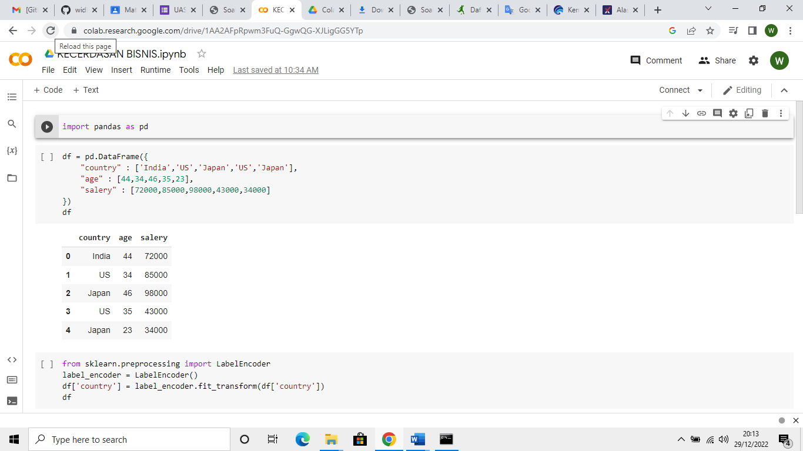

B. 